**OPERATING SYSTEM CONCEPTS**

**( ITPC – 224 )**

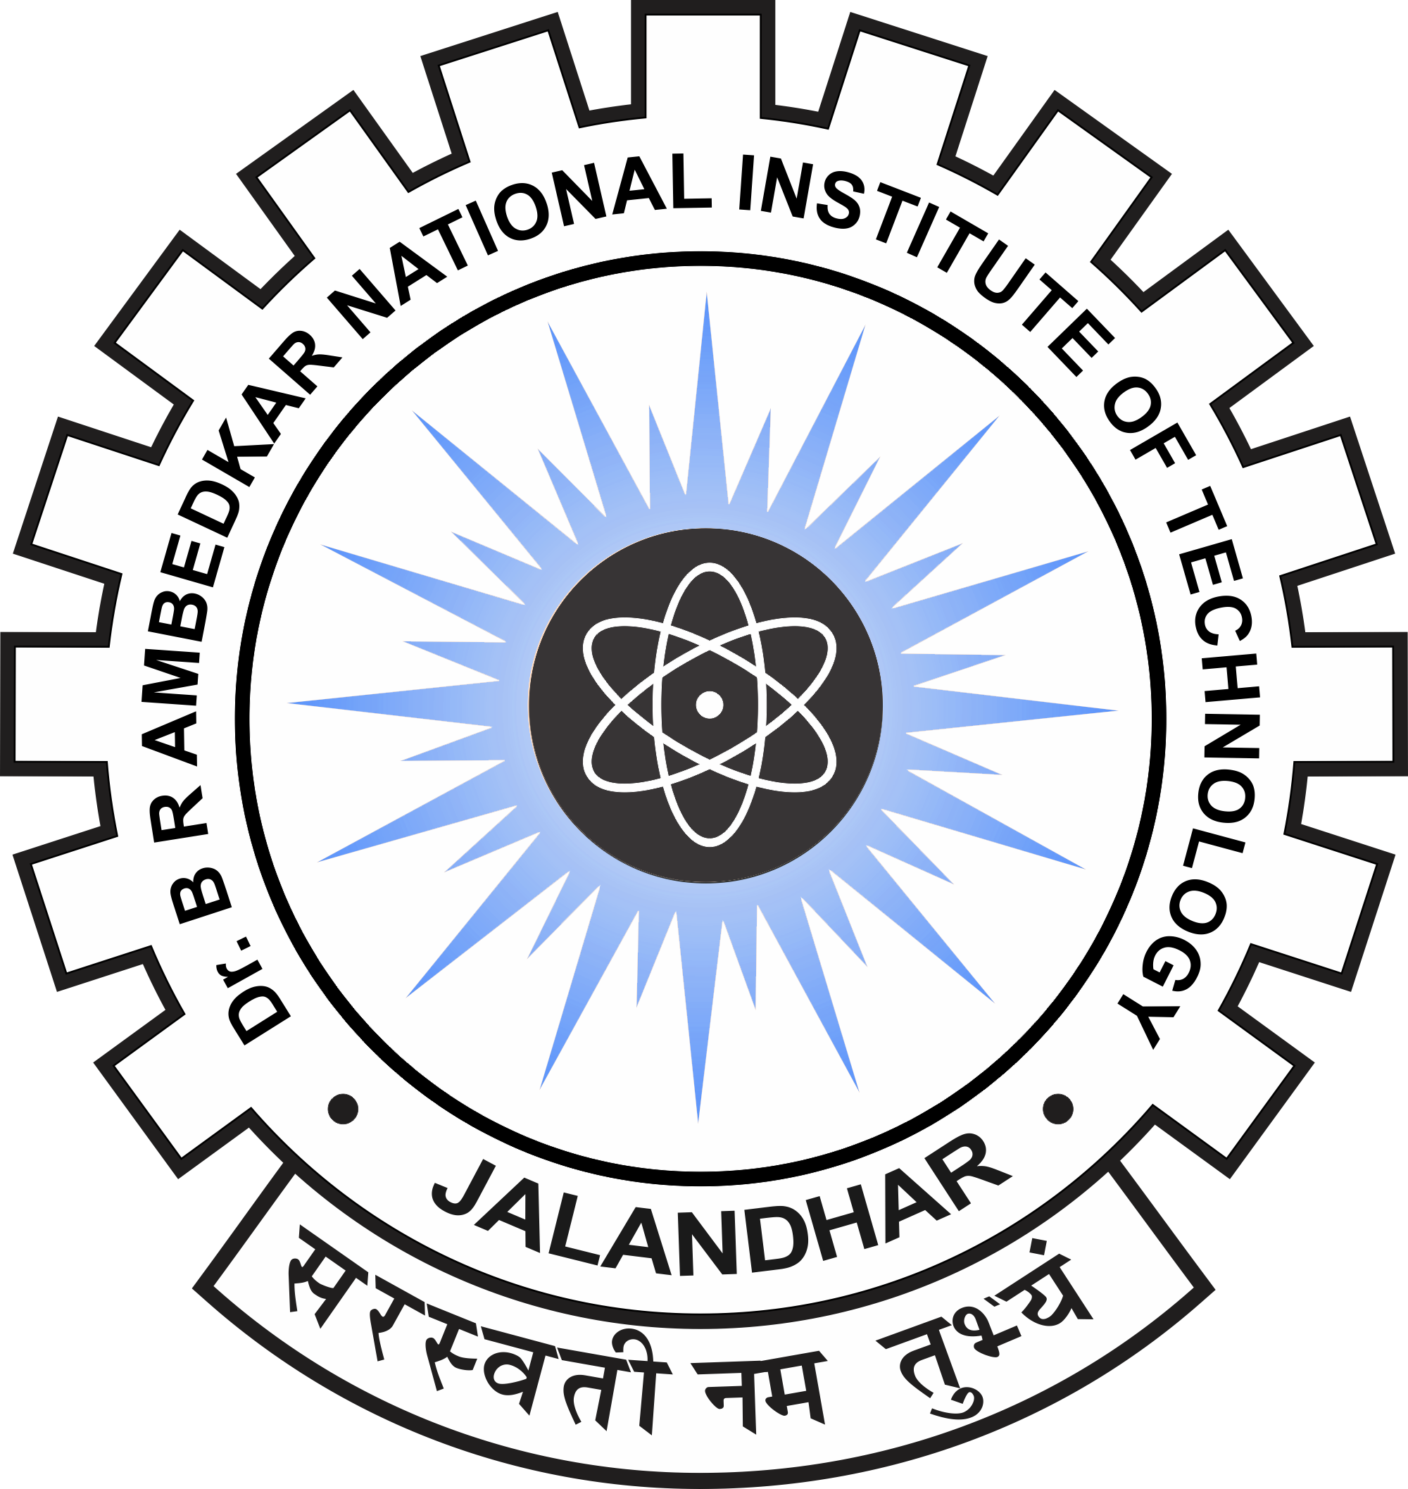

**Dr. B R Ambedkar National Institute of Technology, Jalandhar**

**Punjab- 144011**

**SUBMITTED TO : SUBMITTED BY :**

Er. D.K. Gupta Arvinder Sngh

Assistant Professor 18124004

IT/4th Semester